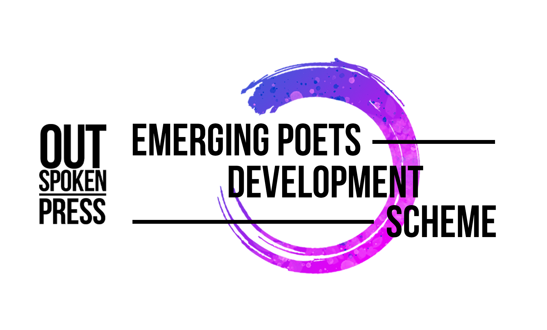
Submission Form for Postal Applications

Please ensure that you have read the Terms & Conditions, and the Eligibility Guidelines provided.

Please complete each section below and return this form, together with the attachments to: EPDS Out-Spoken Press, Unit 39 Containerville, 1 Emma Street, London E2 9FP. Submissions must be received no later than 17 February 2022.

Name: __________________________________ DOB: _________

Address: __________________________________
__________________________________
__________________________________
__________________________________

Email: __________________________________

Telephone: __________________________________

I confirm I am enclosing the following:

▢ a sample of poems (up to 5 poems, or 4 pages of A4, whichever is longer); and

▢ a short covering letter (no longer than a single side of A4) introducing us to who you are and the types of themes or concerns you see your work exploring, your aims, and what you would hope to gain from a place on the Scheme.

I have been provided with a copy of the Terms & Conditions and Eligibility Guidelines for the Out-Spoken Press Emerging Poets Development Scheme and agree to be bound by their provisions.

____________________________ ( __________________ )
Signed Date

Terms & Conditions
1. Applications from writers resident in the North of England (defined as the areas covered by Arts Council England in Yorkshire, North East and North West) will be accepted through the Northern Writers’ Awards application process, and subject to its eligibility criteria, terms and conditions, set out here: www.northernwritersawards.com
2. All other applications will be accepted online through our Zealous page: https://zealous.co/outspokenpress/opportunity/Emerging-Poets-Development-Scheme/ or via paper form sent to us by post at EPDS Out-Spoken Press, Unit 39 Containerville, 1 Emma Street, London E2 9FP, or by audio/video submission arranged by email, and in each case subject to the terms and conditions set out below. If you have access requirements and need assistance to apply please contact press@outspokenldn.com. To qualify, an application must consist of three items: the completed submission form, a covering note, and a sample of the creative work in progress the applicant would like to develop as part of the programme.
3. Incomplete applications will not be considered or acknowledged.
4. Applications must be written by a single author who meets the eligibility criteria of the Scheme.
5. All work submitted must be the individual and original work of the applicant.
6. Applicants must be permanently resident in the UK.
7. Applications must be in English.
8. Applications received after the deadline of 11pm on 17 February 2022 will not be accepted.
9. The writing sample sent as part of your application should be 12-point font and paginated.
10. Entries will be judged anonymously. To that effect, please do not include your name on any uploaded documents. This includes your writing sample. Any writing samples with names or identifying information on them will render the application disqualified.
11. Only one application will be considered per writer. If you apply more than once only your first application will be considered.
12. Due to the volume of applications, we will not be able to offer any feedback on applications.
13. Successful applicants must be available to attend all the activities associated with the Scheme, including one-on-one mentoring sessions, critical feedback groups, and workshops. All reasonable effort will be made to schedule such events at a time when successful applicants are available.
14. The Scheme will be delivered online. Participation in the programme is free at the point of delivery. Travel and other costs associated with participating in the Scheme will not be covered by Out-Spoken Press or our project partners.
15. Out-Spoken Press reserves the right to ask a successful applicant to leave the programme if they fail to attend activities without a valid reason, break our code of conduct, or are found to have fabricated any information or material in their application.
16. Out-Spoken Press will make final decisions on eligibility. Our decisions are final, and no correspondence will be entered into on the subject. Please also refer to the eligibility criteria document.
17. Successful applicants must be available to participate in media and PR for the Scheme.
18. It is the writer’s responsibility to inform Out-Spoken Press if they are offered a contract to sign up with an agent and/or publishing contract during the application and judging process. In this case you will become ineligible for the Scheme.
19. Judges, their close family members, employees or trustees of Out-Spoken Press, Out-Spoken, Spread the Word, New Writing North or our major supporter Arts Council England are not permitted to apply.
20. Submission of an application to the Emerging Poets Development Scheme will be taken to mean acceptance of these terms and conditions. Entries that fail to comply with these terms and conditions will be disqualified.
21. The judges’ decision is final and no correspondence or discussion about the judging process will be entered into.
22. Out-Spoken Press reserves the right to alter dates, timeline, and terms and conditions stated above should it be necessary for any reason.

Eligibility Criteria
1. Applications are open to writers aged 18+ who live in the UK. Successful applicants will be asked to provide proof of address.
2. If you are currently or are about to be enrolled in a graduate or postgraduate creative writing programme (BA, MA or PhD) you are not eligible to apply. If you have completed a BA, MA or PhD in creative writing in the last two years, you are also not eligible to apply.
3. If you are part of a longer-term development programme during the application window and programme activity (e.g. Jerwood Arvon Mentoring scheme, Penguin Random House Write Now, Faber Academy, London Libraries Emerging Writers scheme etc) you are not eligible to apply.
4. Applicants should be Emerging. We define this as meaning:
a. You do not currently have a literary agent representing you;
b. You have not previously published a full-length collection of poetry;
c. Previously self-published writers can apply with a currently unpublished work.
5. If you are offered a contract to sign up with an agent and/or publishing contract prior to the commencement of the programme (i.e. during the application and judging process), you are ineligible for the Scheme.
6. Judges, their close family members, employees or trustees of Out-Spoken Press, Out-Spoken, Spread the Word, New Writing North or our major supporter Arts Council England are not eligible to apply.

